IT 166 Lab 12

Time Series in pandas

Objectives

* Be able to use pandas to solve simple time series problems.

Preparation

* Launch the Jupyter notebook.
* Rename the notebook page as “lab12”.
* Solution to one problem should occupy one cell.

Please provide solutions to the problems below.

Problem 1

Use pandas to read the Apple stock file (AAPL.csv) and set the Date column as the index. Select the information for the entire year of 2016. Plot the open and the high prices using lines.

Requirements:

1. Two plots should co-exist in one figure.
2. Set the legend. (Hint: pass ‘legend=True’ to the plot function.)

Find out the mean of the close prices in May and June of 2016. Compute the difference between the two values by subtracting the former one from the latter one.

Requirement:

1. Round the digit to the nearest hundredth

Expect outcome:

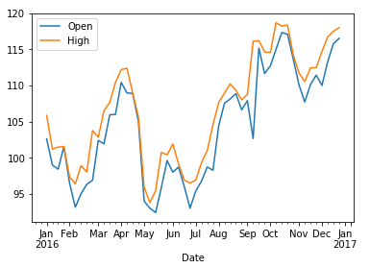



Problem 2

1. ############

The 2018 Fall semester at Illinois State University starts on August 20 and ends on December 14. Use the date_range function in pandas to generate a student academic calendar.

Requirement:

1. The calendar should include all the weekdays, excluding all the weekends.
2. Notice that ISU students will not have classes from 11/19 to 11/23 due to the Thanksgiving break. Therefore, the calendar should not have those dates as well.

Hint:

* The best way to do this is to create your own ISUFall2018Calendar class, by following the example given in the lecture.
* In this class, you need to manually add dates from November 19 to November 23 as holidays.

Count the number of days in the calendar.

1. #############################

Since you are taking IT 166, which is offered every Monday and Wednesday. Generate a calendar for the course.

However, for this calendar, you need to remove the final exam week, which is from 12/10 to 12/14.

Hint:

* To remove dates from a calendar, you can use the following code:

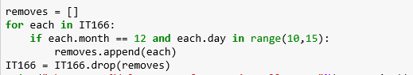

Expect outcomes:

